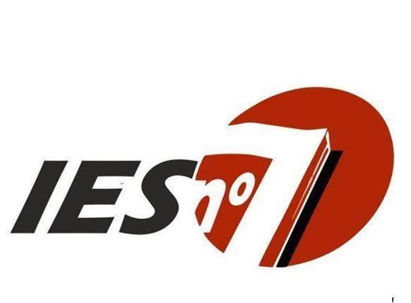

CARRERA: Tecnicatura Superior en Desarrollo de Software
UNIDAD CURRICULAR: Inglés Técnico I
PROFESORA: Lic. Gabriela Noemí Duaigües
Programa de exámenes año 2019

CONTENIDOS:

Unit 1: Working in the IT business
- Meeting people
- Jobs in IT
- Schedules
- Spelling
- Business matters
Unit 2: Computer systems
- Computer hardware
- Computer software
- Working with computers
- Computer usage
- Business matters
Unit 3: Websites
- Website purpose
- Website analytics
- Website development
- The best websites
- Business matters
Unit 4: Databases
- Database basics
- Data processing
- Data storage and back-up
- Database systems benefits
- Business matters
Unit 5: E-commerce
- E-commerce companies
- E-commerce features
- Transaction security
- Online transactions
- Business matters
Unit 6: Network systems
- Types of network
- Networking hardware
- Talking about the past
- Network range and speed
- Business matters
Unit 7: IT support
- Fault diagnosis
- Software repair
- Hardware repair
- Customer service
- Business matters
Unit 8: IT security and safety
- Security solutions
- Workstation health and safety
- Security procedures
- Reporting incidents
- Business matters

BIBLIOGRAFÍA:

- “English for Information Technology I”, Olejniczak, Maja. Pearson.

Prof. Lic Gabriela N. Duaigües

